English Homework: Autumn 2, Week 2

Name: ________________________ Date: ____________

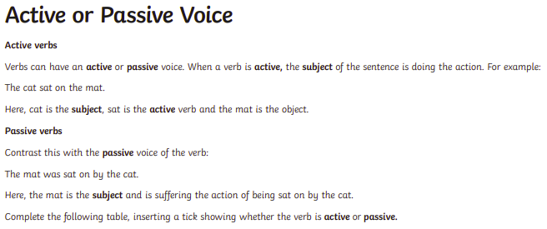
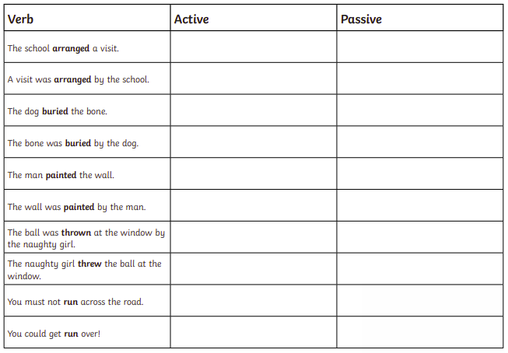

Change these active sentences to passive ones:
- James climbed the ladder.
____________________________________________________________________

- A stone smashed the window.
____________________________________________________________________

- The boys pushed the tree over.
____________________________________________________________________

Change these passive sentences to active ones:
- The football was kicked by Luke.
____________________________________________________________________

- The book was left on the table by Julie.
____________________________________________________________________

- The milk had been knocked over by a cat.
____________________________________________________________________

