**Year 4 Geography Homework**

**Kenya Research Display Project**

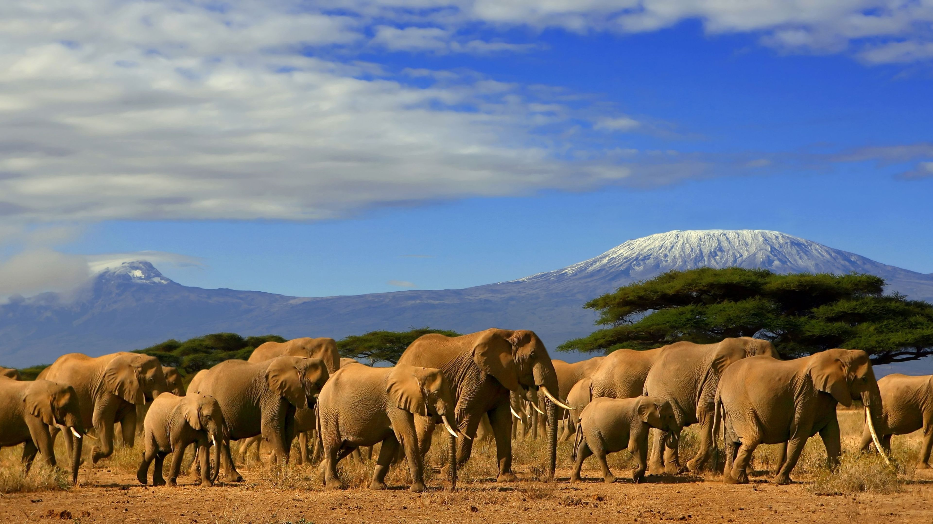

**Start date:** Friday 25th October

**Completion date**: Friday 8th November

**Geography Homework (Kenya Research Display Project) explained:**

This homework project is linked to our Geography topic being studied in the Autumn Term entitled ‘Grasslands to Deserts’. The children have been learning about their local area, the Northwest of England, habitats, vegetation belts and climate zones. The next phase of our Geography topic this term is to compare our region with that of the Country of Kenya. In preparation for this, the homework challenge is to find out some facts about Kenya and produce a piece of work that can be placed on display.

**Possible ways in which your child can present their facts about Kenya:**

1. Picture, poster, drawing, sketch, painting of a Kenyan landscape / Kenyan wild animal
2. Picture / painting with some facts about Kenya incorporated
3. A Fact File Poster, Top Trumps cards on animals found in Kenya.
4. An Information Leaflet
5. Amazing fact file (Kenya’s Top 10 Most Amazing Facts)
6. The Kenyan Flag
7. A map of Kenya with key landmarks labelled
8. A 3D model of a Kenyan animal.

**Key Information your child could research about Kenya:**

1. Size, Population, Capital City, Flag, Major Religion, Culture, Wildlife, Climate, environment, Major mountain ranges, currency, language.
2. Your child can add any other interesting facts that they find out about Kenya.

I would like to celebrate your child’s homework in class on Friday 8th November so please can they be brought into school or emailed to me on or before this date.

Kind Regards,

Alex Goodwin